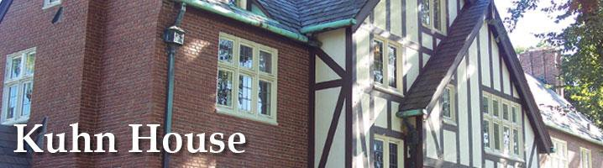

Usage Guidelines

Serving as the home of Ohio State Presidents until 1972, Kuhn Honors & Scholars House now serves as the administrative offices for the Office of Academic Enrichment and its departments including University Honors, The Ohio State Scholars, Undergraduate Research & Creative Inquiry, Undergraduate Fellowship Office, and Service-Learning and Community-Engaged Teaching.

Below are the rules when using the House for an event:
- Individuals or groups who reserve room(s) are responsible for the actions and behaviors of all of their members/students/peers.
- Any room(s) used by your group must be left as they were found.
- All furniture must stay in its original location. No furniture is to be taken outside.
- Trash must be disposed of in the kitchen. Leftover food must be disposed of in the dumpsters located through the side door in the kitchen.
- Please note that we cannot supply cookware, utensils, serving platters, coffee, or dishwashing service for your group.
- The kitchen must be cleaned after it has been used, and all catering and food items taken away at the end of the event. Cleaning supplies and additional garbage bags are found below the kitchen sink.
- Food refuse must be placed in the outdoor trash at the loading dock.
- Clean the sink and wipe down all appliances and surfaces used.
- Each group is responsible for paying the cost of any cleaning/repair services needed following an event.
- Alcohol is not permitted in the House.
- We reserve the right to alter room locations, or if necessary, cancel a group's reservation.
- Cancellation of reservations should be received at least 48 hours before the event is scheduled.
- If your event is catered, please work directly with your caterer, rather than having them contact our Building Coordinator.
- All events must have an OAE staff member on-site for the duration of the event. This is particularly important outside of normal operating hours.
- If your event is outside of normal business hours and space is available and:
  - You are an OAE staff member and work at Kuhn House, your event can move forward
  - You are an OAE staff member and do not work at Kuhn House, you will need to provide your BuckID # before we can confirm the space to you. Once we receive your BuckID # you can move forward with using the space
    - Stop by the front desk to pick up a key, the student worker will explain the opening and closing procedure and what to do in the event of accidentally triggering the alarm.
  - You are not an OAE staff member:
    - A student staff member must be onsite to open/close and will be available to answer questions. Your organization will be charged for the cost of student staffing. Your event is not confirmed until we are able to secure student staff coverage.
- All events must adhere to the Kuhn usage guidelines regarding cleanup and proper care of the House. If guidelines are not followed, you will lose booking privileges.
- The fireplace cannot be used.

